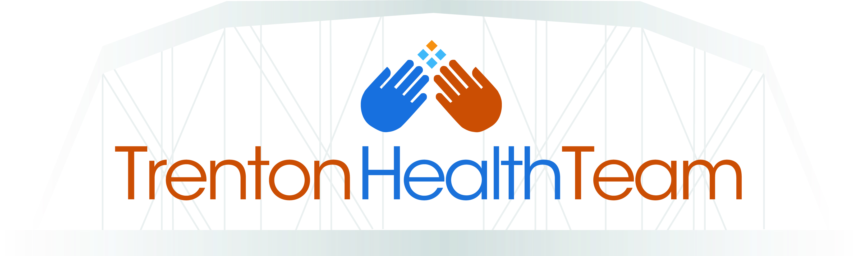

Trenton Health Team Receives ‘Innovation Award,’
Presented by athenahealth, at HIMSS18

Trenton, NJ – March 7, 2018 – Trenton Health Team, an innovative organization taking a collaborative approach to transforming health and health care in Trenton, NJ, will be honored as an Innovation Award recipient, presented by athenahealth, Inc., at the 2018 Healthcare Information and Management Systems Society (HIMSS) Annual Conference and Exhibition, and will be recognized during a fireside chat with Gregory Paulson, Executive Director of Trenton Health Team, at athenahealth’s booth (#119) on Wednesday, March 7, at 2:30 PM. Trenton Health Team was nominated for its central role in a robust multi-sector collaboration model, utilizing partnerships and expertise from over 60 clinical and community organizations to improve care delivery and reduce health disparities in the city.

“We are honored to be recognized as an innovator in the healthcare landscape. Since our founding, we have focused on transforming healthcare for and with the community,” said Gregory Paulson, Executive Director of Trenton Health Team. “This Innovation Award is a reflection of the trust, respect, and partnership our collaborative has built. By coming together as partners instead of competitors, we are able to strengthen our network to have a long-lasting impact.”

“At athenahealth, we are constantly striving to celebrate the players who are disrupting and transforming healthcare,” said Jonathan Bush, CEO of athenahealth. “We know there is real opportunity to share tangible, effective innovations that can be replicated at other organizations, regardless of scope, size, or location. This year at HIMSS, we’re thrilled to launch the Innovation Awards and recognize programs that are driving meaningful change in care delivery and organizational outcomes across the country.”

athenahealth is a network-enabled, results-oriented services company that offers medical record, revenue cycle, patient engagement, care coordination, and population health services for hospital and ambulatory clients. The company’s vision is to build a national health information backbone to help make healthcare work as it should.

To learn more about the Innovation Awards, please visit athenahealth’s website.

About Trenton Health Team
Trenton Health Team (THT) is a community health improvement collaborative serving the six zip codes of Trenton, NJ. The collaborative is an innovative partnership among Capital Health, St. Francis Medical Center, Henry J. Austin Health Center, and the Department of Health and Human Services of the City of Trenton. The vision of the Trenton Health Team is to make Trenton the healthiest city in the state. Our mission is to transform healthcare for the city by forming a committed partnership with the community to expand access to high quality, coordinated, cost-effective healthcare. For more information, visit: www.trentonhealthteam.org or follow us @trentonhealth.

Media Contact Info
Martha Cook Davidson
Trenton Health Team
mdavidson@trentonhealthteam.org
(609) 256-4555 x172

